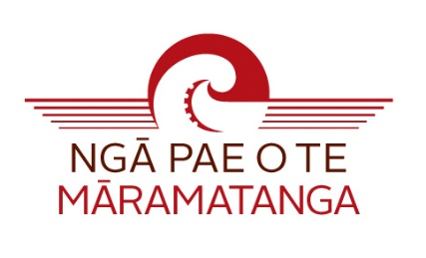
2018 PUBLICATION SUPPORT GRANT
INFORMATION AND GUIDELINES FOR APPLICANTS

Purpose
This grant is for Māori researchers to publish and/or disseminate their research findings. The types of media is deliberately diverse and includes, but is not limited to, written, electronic, visual, audio forms. Applications must demonstrate how they contribute to Indigenous research development and the Research Programme of Ngā Pae o te Māramatanga (NPM).

Applicants are encouraged to follow the application guidelines and requirements carefully, and to ensure the budget is justified and reasonable. Applications will be assessed individually on their own merits.

Eligibility: For emerging and established researchers at NPM partner institutions.

Duration: Grants are awarded for a period of one year.

Applications

Applications open on 1 March 2018 and close at 5.00pm on 26 April 2018. Applicants will be notified of the result at the earliest opportunity.

Please apply online
2018 Publication Support Grant
Application form

- Details of Applicant
Name (and title if applicable)
Iwi affiliation
Institutional Student ID number (if applicable)
Organisation/Company
Postal address

Telephone
Mobile
Email address
Employment status | - Fulltime  - Part-time  - Other  - Please specify
Have you previously received any other source of funding from NPM? | Yes/No
If yes, please outline the type and value of funding received
Referees, please include three referees names and their contact details

Upload the following requirements of the Publishing Support Grant application
Publication details (please provide a description of the planned work including the following. Do not exceed five pages ):  - Proposed full title of the work or creation  - Intended publisher (if known or applicable)  - Type of media that describes the output or final product/creation (e.g., written, electronic, visual, audio etc.)  - Description of final output/creation  - General description of the contents, methods and processes  - Describe how this work aligns with or contributes to the Research Themes of NPM  - How does this work/creation contribute to the body of knowledge that is concerned with Māori development?  - Is this a special case e.g., developing new area of research; fostering collaboration; developing initiatives; developing capability? If so, how?  - Enhancing and using te reo ma ngā tikanga Māori (briefly explain how the work/creation will contribute to enhancing the revitalisation and normalisation of te reo Māori within our research settings, communities and/or society).  - Te Reo Māori Expert (Where Māori language is used in the publication, we require that a suitably qualified Māori language expert undertake a Māori language edit.). Name the person who will undertake this Māori language edit for you and briefly outline their qualifications - formal and/or non-formal.  - Does the work/creation use photos or images? (Note permission to use all photos and images is required). Please confirm image types and permission status or arrangements to gain permission.  - Dissemination  - Outline the dissemination strategy for the publication, including key audiences, expected numbers of participants and any other events associated with the sharing of the research output/publication. | a
Proposed Budget  - Provide details and supporting documentation, including quotes, for the budget items. (Download the Budget template here). Once completed upload your budget along with the online application) | Please attach
Curriculum Vitae: Please complete the RSNZ template provided (Download here). | Please attach

