**Ngā Pae o te Māramatanga Whakaaweawe Grant Round 2025**

# GRANT APPLICATION

*CLOSING DATE 01 September 2025, 5.00PM*

Ngā Pae o te Māramatanga (NPM) is inviting applications for our 2025 Whakaaweawe Impact and Transformation Grants.

## Purpose

NPM Whakaaweawe Impact and Transformation Grants support Māori researchers employed at a NPM partner entity to achieve research outcomes and knowledge sharing pathways that harness connectedness and promote research uptake and impact.

## Supported activities

The types of activities supported by this grant might include individual or collective outputs including artistic works, performances, and creative designs, policies, or processes. They might also include activities that lead to scholarly books, journal articles, impact and/or policy briefs and other nationally and internationally published outputs and presentations that offer new, recovered, or reinterpreted knowledge.

Examples of what the grant might be used for including: creating digital assets including film, photography, infographics, illustrations; creating interactive experiences such as board games and exhibitions; creating performative or artistic articulations of research findings such as film and compositions; publication and final editing costs; Open Access expenses; hosting or attending an in-person event, hui, wānanga or conference.

Successful applicants in the past have used this grant to support research outputs that have included books, journal articles, free online resources, app development, compositions (e.g. waiata and haka), translation of existing work into te reo Māori for publication, and to attend and present research at conferences.

## Eligibility

The lead applicant must be a Māori researcher employed at an NPM partner entity.

## Duration

All projects need to be completed within 12 months to meet NPM contract obligations. All funding should be spent by 30 June 2026, unless otherwise agreed with NPM.

## Value

We expect to support a mix of 10-15 grants, valued up to $3,000 and larger grants up to $7,000, from a total funding pool of $50,000 NZD.

For applicants seeking support to present an accepted, peer-reviewed paper at an academic conference, the maximum that may be applied for is $2,500 and may be used to cover registration at online or in-person conferences, travel and accommodation.

## Closing Date

01 September 2025, 5.00pm

## How to apply

Applications must be submitted through the NPM online application portal. Please ensure your application includes:

1. Completed 2025 NPM Whakaaweawe - Impact and Transformation Grant Application, including the budget section and any supporting quotes or evidence.
2. Lead Researcher’s CV, using the New Zealand Standard Curriculum Vitae Template.

## INSTRUCTIONS

1. **Fill out the application form offline first.** The online form can time out, so it’s best to prepare your answers in the offline version before starting the online form.
2. **Prepare all associated files for uploading**, such as the Lead Researcher’s CV and any supporting quotes or evidence.
3. **Remove the information and instruction pages** (Pp 1-2) from your application document.
4. **Delete all text that is coloured grey**.
5. **Make sure your answers are written in black font, size 11 or bigger**, and that all sections of the form are filled in.
6. **Open your final version of the application** and start the online form.
7. **Copy and paste your answers** from the offline form into the online form. Fill in any extra details if asked.
8. **Give your files clear names** that describe what they are and upload them under the right headings.
9. **Upload all the files** that are part of your application.
10. **Check everything carefully** before you submit.
11. **Click the 'Submit' button and wait for the confirmation message on screen.** You won’t receive a confirmation email, so please make sure you see the message before closing the page.

**You must do this for your application to be sent.**

More information regarding applications is available through the online application portal:

[<https://auckland.au1.qualtrics.com/jfe/form/SV_6sQOK8wGgGxbDyS>]

## Contact

For application queries please email: [research@maramatanga.ac.nz](mailto:research@maramatanga.ac.nz).

## Matakitenga Framework

You can view the framework in Appendix 1 at the end of this document or [online here](https://www.maramatanga.ac.nz/research/matakitenga-framework) or [download a copy](https://www.maramatanga.ac.nz/media/7082/download).

# NGĀ PAE O TE MĀRAMATANGA

# 2025 WHAKAAWEAWE GRANT APPLICATION

# SECTION 1 - OVERVIEW

## Lead Researcher Details

|  |  |
| --- | --- |
| Lead Researcher Name | *Title, First, Last name* |
| Iwi affiliation/s | *Separate iwi with a comma* |
| NPM Partner Entity | *(Where Lead Researcher is employed)* |
| Position at Partner Entity | *(e.g., Professor, Research fellow, lecturer)* |
| Email | *(work email)* |
| Work/Mobile number |  |

## Whakaaweawe Project title

|  |
| --- |
| Provide a descriptive title not more than two lines long |

## Lay summary

|  |
| --- |
| Provide a lay summary (max 200 words) of the project that may be shared publicly. Include a brief background to the project, the research question(s), project aims and objectives, and why the research is important. Outline the impact and transformation effects that this grant will enable as this is the primary focus of this grant. |

## Alignment

Which Pae or Rautaki is this research most aligned to? Check one only. Refer to the NPM Matakitenga Research Framework ([Appendix 1](https://www.maramatanga.ac.nz/research/matakitenga-framework))

|  |  |  |  |  |  |  |  |
| --- | --- | --- | --- | --- | --- | --- | --- |
| Ahurei |  | Ora |  | Tawhiti |  | Auaha |  |
|  |  |  |  |  |  |  |  |
| Kounga |  | Whakaaweawe |  |  |  |  |  |

Which Pātai is this research most aligned to? Check one only.

|  |  |  |  |  |  |  |  |
| --- | --- | --- | --- | --- | --- | --- | --- |
| Te Ao Māori |  | Whānau |  | Mauri |  | Puāwai |  |

# SECTION 2 – WHAKAAWEAWE PROJECT OUTCOMES AND IMPACT

## What do you expect to achieve with this whakaaweawe project, and what will its impact be?

|  |
| --- |
| *Provide a brief description of the expected achievements and impact of this project with an emphasis on the dissemination of the research that this grant will enable. (2 lines max)* |

## What are your whakaaweawe project objectives and expected completion dates?

An objective is a research task to be achieved (e.g., design wānanga, obtain ethical review, hold community hui, deliver stakeholder policy seminar, submit manuscript). You should list a minimum of three objectives.

|  |  |  |
| --- | --- | --- |
|  | Whakaaweawe grant objectives | Completion date |
| **1** | *DELETE (complete and obtain ethical review)* | *DD/MM/YY* |
| **2** | *DELETE (recruit and complete 20 interviews)* | *DD/MM/YY* |
| **3** |  |  |
| **4** |  |  |
| **5** |  |  |
| **6** | Complete all NPM reporting requirements | 30/06/26 |

*Expand as required*

## List 3-5 Matakitenga outcomes your whakaaweawe project relates to directly.

Please refer to the outcome statements in the NPM Matakitenga research framework. The Matakitenga indicator are the 4 characters that precede the outcome statement.

|  |  |  |
| --- | --- | --- |
|  | **Matakitenga indicator** | **Matakitenga outcome statement** |
| **1** | *(e.g., AAH1)* | *DELETE (e.g., Research to protect, regenerate and future proof Te Ao Māori)* |
| **2** |  |  |
| **3** |  |  |
| **4** |  |  |
| **5** |  |  |

*Expand as required*

## How will your whakaaweawe project contribute to the Matakitenga outcomes you have listed above?

|  |  |  |
| --- | --- | --- |
|  | **Matakitenga indicator** | **Research Contribution** |
| **1** | *(e.g., AAH1)* | *DELETE (e.g., Our research will emerge novel Te Ao Māori inspired conservation strategies for urban application)* |
| **2** | *(e.g., PAU4)* | *DELETE (e.g., Our bi-weekly project newsletter will create discussion and nurture the ethical use of digital marae platform)* |
| **3** | *(e.g., MTA3)* | *DELETE (e.g., Our policy focused journal article and high impact webinar will influence economic awareness and policy for mana and mauri centred decision-making).* |

*Expand as required*

# SECTION 3 – WHAKAAWEAWE PROJECT PLAN

## Tell us what your proposed whakaaweawe project is about and why it matters.

Include reference to any significant previous research in the field, and the contribution expected to be made by the proposed research. What evidence can you provide that your project will facilitate connectedness, reciprocity and an uptake with research stakeholders and communities.

|  |
| --- |
| (Half page max) |

*Expand as required*

## Where will the research take place? (check all that apply)

Include reference to any significant previous research in the field, and the contribution.

1 Northland - Te Tai Tokerau

2 Auckland - Tāmaki-makau-rau

3 Waikato

4 Bay of Plenty - Te Moana-a-Toi

5 Gisborne - Te Tairāwhiti

6 Hawke's Bay - Te Matau-a-Māui

7 Taranaki

8 Manawatū-Whanganui

9 Wellington - Te Whanga-nui-a-Tara

10 Tasman - Te Tai-o-Aorere

11 Nelson - Whakatū

12 Marlborough - Te Tauihu-o-te-waka

13 West Coast - Te Tai Poutini

14 Canterbury - Waitaha

15 Otago - Ōtākou

16 Southland – Murihiku

## Community of Interest

A “Community of Interest” may be an iwi or hapū group, a group of landowners or beneficiaries, a community that shares a commonality (e.g., students, athletes), or group that seeks to advance a goal (e.g., ending racism, better health services).

If you are working with a Community of Interest, please name and briefly describe the nature of the engagement.

|  |  |
| --- | --- |
| **Community name** |  |
| **Nature of engagement** |  |
| **Community name** |  |
| **Nature of engagement** |  |

*Expand as required*

## Who is the intended audience for your whakaaweawe project?

|  |
| --- |
| (Half page max) |

*Expand as required*

## If relevant, indicate how you will meet the data sovereignty requirements of Māori community partners and/or Māori participants.

|  |
| --- |
| (Half page max) For further information and related resources please visit Te Mana Raraunga Māori Data Sovereignty website [here](https://www.temanararaunga.maori.nz/). This section focusses on Indigenous Data Sovereignty, rather than ethical application and approval. |

|  |  |
| --- | --- |
| **TE REO MĀORI EXPERTISE** | |
| *A suitably qualified Te Reo Māori expert must undertake a Te Reo Māori edit for all Te Reo Māori content included in the final publication. If this applies to this project, name the person who will undertake this edit and briefly outline their qualifications - formal and/or non-formal.* | |
| Name: | Qualifications: |
| **FOR PUBLICATIONS PROJECTS COPYRIGHT MATERIAL** | |
| *Will you be using content (e.g., photos, graphics, audio etc) for which permission from the copyright holder is required? Note below the content type and permission status or arrangements to gain permission.* | |
| Content | Permission status or arrangement |
|  |  |
|  |  |
|  |  |

# SECTION 4 - ETHICS

## Did your research in this whakaaweawe project require ethical approval

|  |  |  |  |  |  |  |
| --- | --- | --- | --- | --- | --- | --- |
| Is ethical approval required for the proposed project? | **Yes** |  | | **No** | |  |
| If ‘YES’, please complete the following sections: | | | | | | |
| What type of ethical approval is required? *(Please select what applies)* | **Human Ethics** | |  | | | |
| **Biological Safety Ethics** | |  | | | |
| **Animal Ethics** | |  | | | |
| **Other**-please specify: | |  | | | |
| What is the current status of the required ethical approval? *(Please select what applies)* | Ethical Approval application will be prepared and submitted as part of the proposed research project. | | | |  | |
| Ethical Approval application has been submitted, awaiting approval. | | | |  | |
| Ethical Approval has been granted (please provide approval letter). | | | |  | |
| Other- please provide further detail in the comment. | | | |  | |
| Ethical Approval application will be prepared and submitted as part of the proposed research project. | | | |  | |
| If ‘NO’, please detail why ethical approval is *not required* |  | | | | | |

# SECTION 5 – BUDGET

|  |  |  |
| --- | --- | --- |
| SECTION FIVE – BUDGET | | |
| **2025 WHAKAAWEAWE PROJECT BUDGET** | | |
| ***Proposed Budget*** *(Provide details and supporting documentation, including quotes, for budget items listed below.)* | | |
| **Item** | **Item description** | **Amount** |
| 1 |  |  |
| 2 |  |  |
| 3 |  |  |
| 4 |  |  |
| 5 |  |  |
| 6 |  |  |
|  | **Sub total** |  |
|  | **G.S.T.** |  |
|  | **Total** |  |

*Expand as required*

|  |  |  |  |
| --- | --- | --- | --- |
| **CO-FUNDING** | | | |
| *Please provide details of any funding received, applied for, or intended from other sources (internal or external) to support the activities or items outlined in this proposal.* | | | |
| **YES** |  | **NO** |  |

If **‘NO’**, please outline the situation below.

|  |
| --- |
|  |

If **‘YES’**, please give details in the table below.

|  |  |  |  |
| --- | --- | --- | --- |
| **Co-funder** | **Month & year of application or award** | **$ level of funding secured or requested** | **Status of funding secured or requested** |
|  |  |  |  |
|  |  |  |  |
|  |  |  |  |
|  |  |  |  |

*Expand as required*

**Please note:** you must notify Ngā Pae o te Māramatanga of any other funding received or approved in support of this application as soon as it is known**.**

|  |  |
| --- | --- |
| **SECTION FIVE – SIGNATURE**  **THIS PAGE MUST BE SIGNED** | |
|  | |
| **NPM Lead Researcher name** | *Signature:* |
| *Date:* |

|  |
| --- |
| DOCUMENTS TO BE UPLOADED |
| **2025 WHAKAAWEAWE - IMPACT AND TRANSFORMATION GRANT APPLICATION** |
| *Upload the completed and sign version of this application form* |
| **APPLICANT’S CURRICULUM VITAE** |
| *Upload your CV in RSNZ format (5 pages max)* |
| **QUOTES** |
| *Upload supporting documents that confirm the accuracy of your budget (i.e., quotes especially for significant expenses and sub-contractors).* |

## NPM Matakitenga Research Framework (Appendix 1)

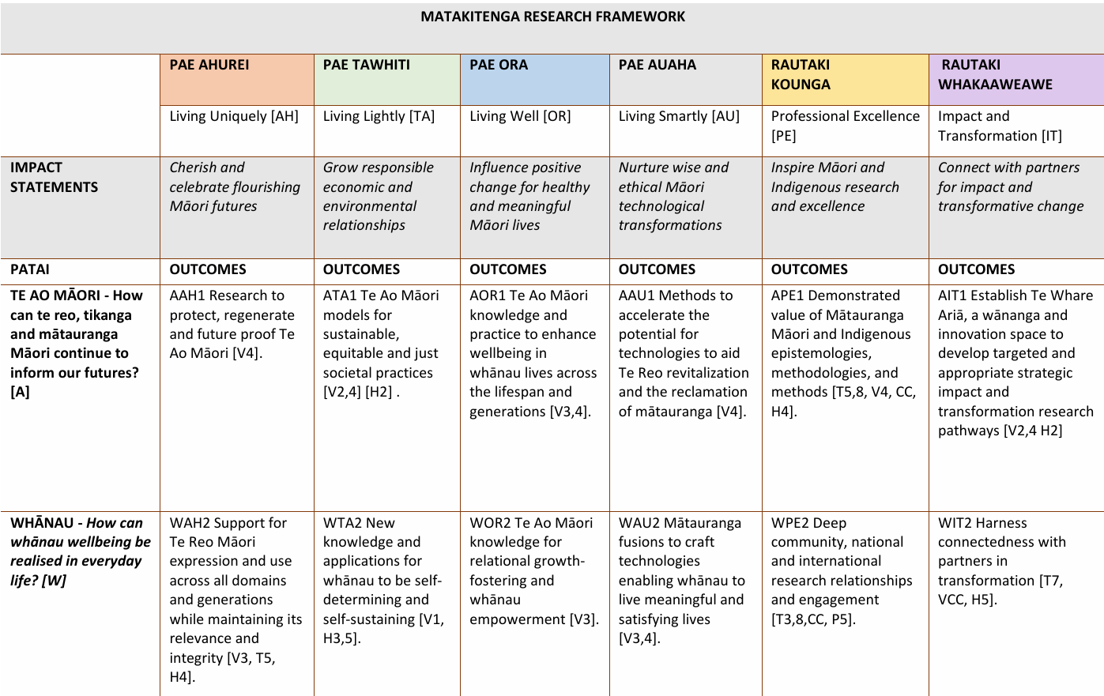

## Matakitenga Framework

You can view the framework [**online here**](https://www.maramatanga.ac.nz/research/matakitenga-framework) or [**download a copy**](https://www.maramatanga.ac.nz/media/7082/download).